**Creating A Social Media Ad Campaign in Facebook**

**Project Description:**

In this project, we will develop a Facebook social media ad campaign with a focus on achieving specific objectives such as increasing brand awareness, driving website traffic, generating leads or sales, and building engagement. We will meticulously identify and define the target audience using Facebook's ad targeting options, allocate an appropriate budget, and set a schedule for the campaign. Our creative team will collaborate to craft engaging ad creatives, including images, videos, ad copy, and headlines, ensuring alignment with the campaign's goals and resonance with the identified audience. Finally, we will meticulously structure the ad campaign within Facebook's Ads Manager, creating ad sets based on different audience segments and ad creatives to optimize campaign performance.

### Creating Ad:

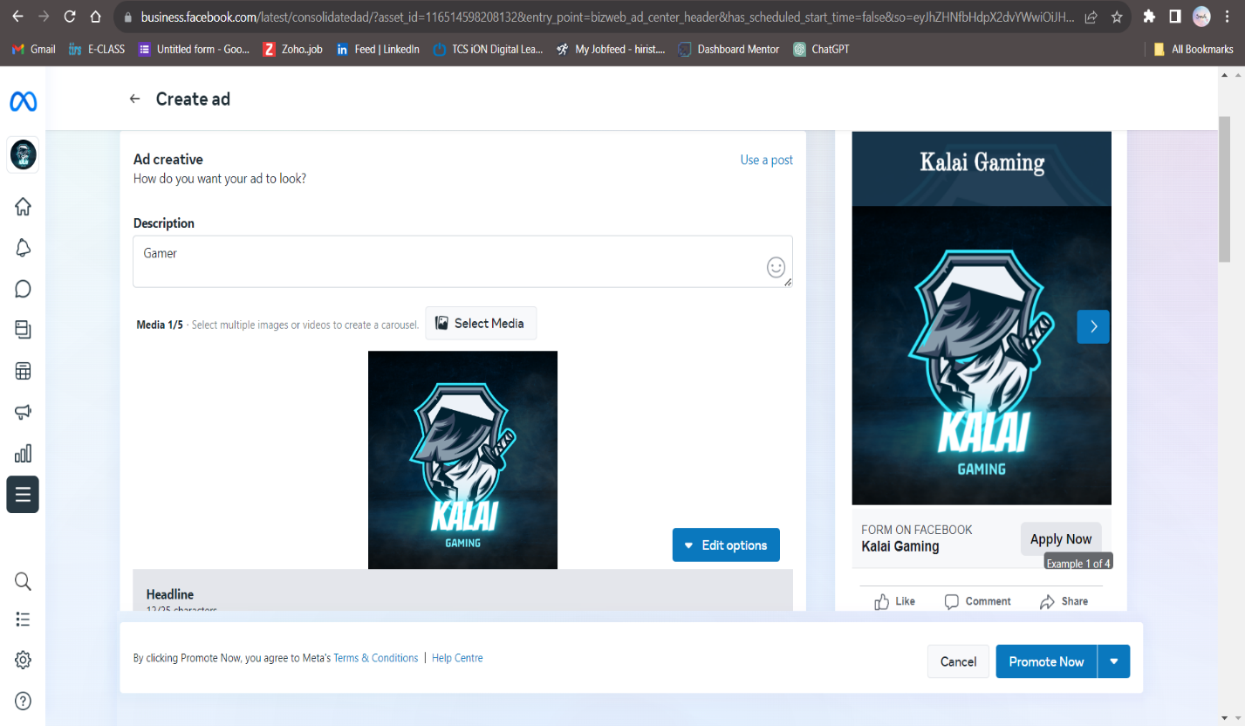

### New Form:

### We create a new form to add our details.

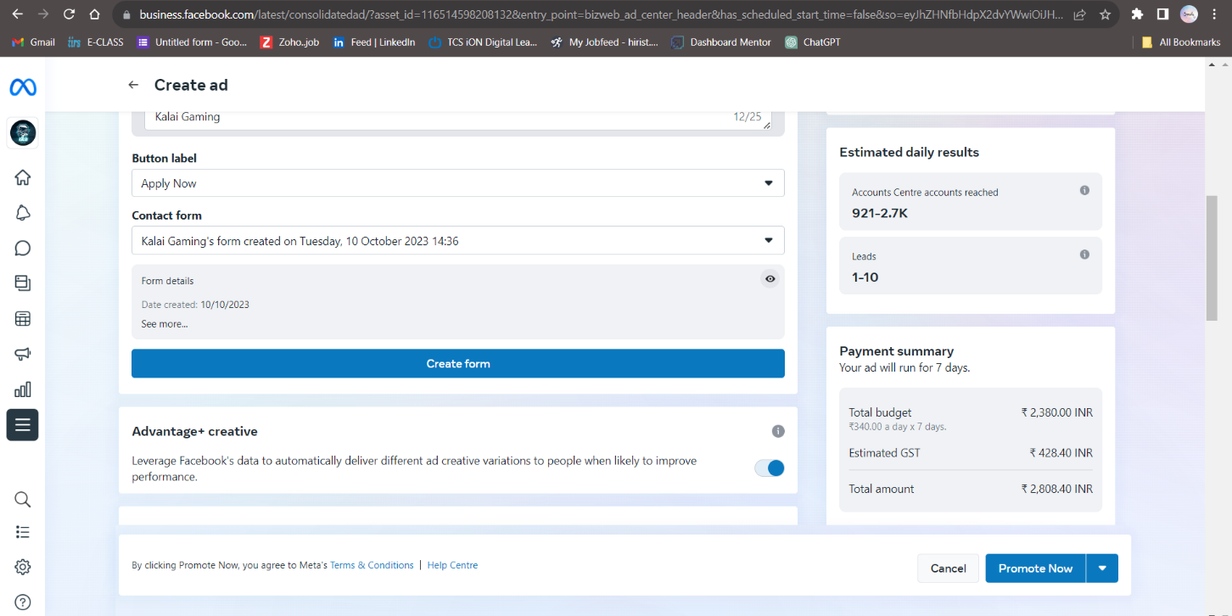

### Description:

### 